TOPIC 3 : DIVIDE AND CONQUER
Programming Exercises and Execution Outputs

Name: Champak Rupesh K
Reg No: 192425123

1. Maximum and Minimum Using Divide and Conquer
Question:
Write a program to find both the maximum and minimum values in an array using divide and conquer.
Input: N=8, a[]={5,7,3,4,9,12,6,2}
Output: Min=2, Max=12
Test cases:
[1,3,5,7,9,11,13,15,17] -> Min=1, Max=17
[22,34,35,36,43,67,12,13,15,17] -> Min=12, Max=67
Code:
def max_min(a):
if len(a) == 1:
return a[0], a[0]
mid = len(a) // 2
mn1, mx1 = max_min(a[:mid])
mn2, mx2 = max_min(a[mid:])
return min(mn1,mn2), max(mx1,mx2)
tests = [[5,7,3,4,9,12,6,2],
[1,3,5,7,9,11,13,15,17],
[22,34,35,36,43,67,12,13,15,17]]
for a in tests:
print("Min =", max_min(a)[0], "Max =", max_min(a)[1])
Execution Screenshot:
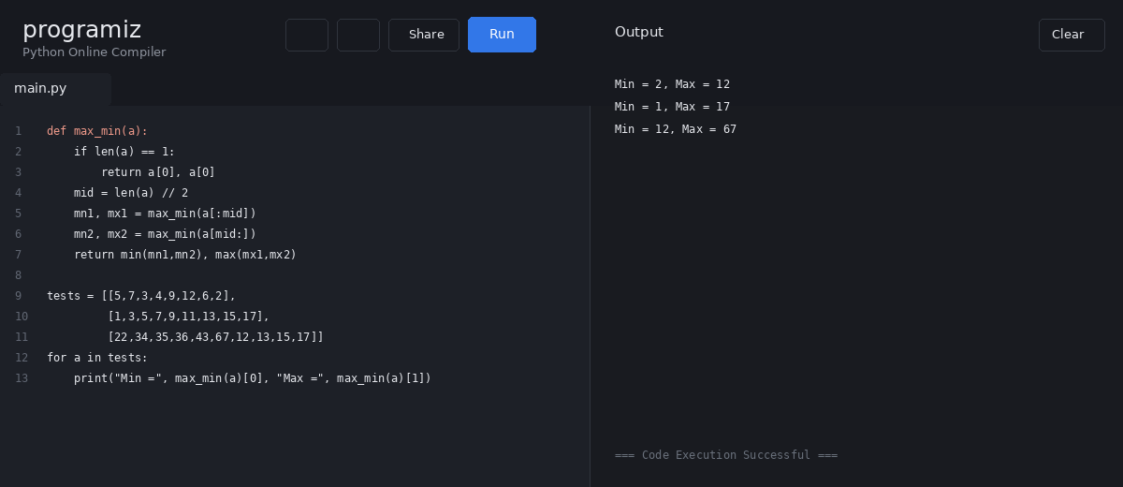

2. Maximum and Minimum in a Sorted Array
Question:
Consider an ascending array 2,4,6,8,10,12,14,18. Write a program to find both maximum and minimum values using divide and conquer.
Test cases:
[2,4,6,8,10,12,14,18] -> Min=2, Max=18
[11,13,15,17,19,21,23,35,37] -> Min=11, Max=37
[22,34,35,36,43,67,12,13,15,17] -> Min=12, Max=67
Code:
def max_min(a):
if len(a) == 1:
return a[0], a[0]
mid = len(a) // 2
mn1,mx1 = max_min(a[:mid])
mn2,mx2 = max_min(a[mid:])
return min(mn1,mn2), max(mx1,mx2)
tests = [[2,4,6,8,10,12,14,18],
[11,13,15,17,19,21,23,35,37],
[22,34,35,36,43,67,12,13,15,17]]
for a in tests:
mn,mx=max_min(a)
print("Min =",mn,"Max =",mx)
Execution Screenshot:
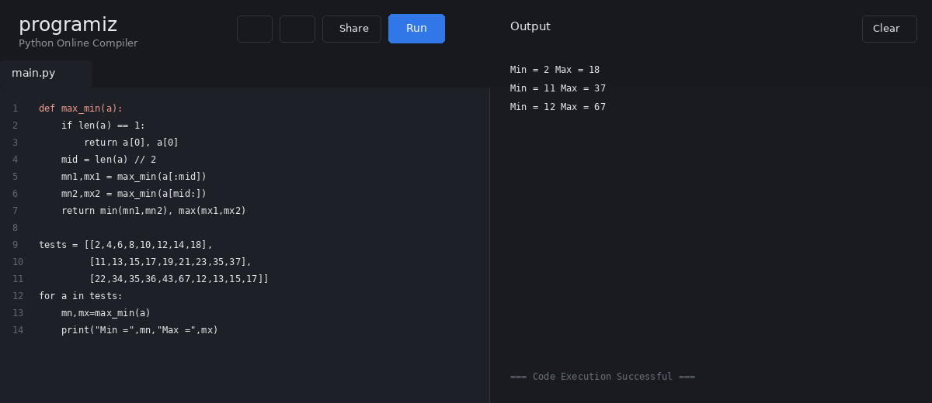

3. Merge Sort
Question:
Given an unsorted array, write a program to perform Merge Sort.
Test case 1:
[31,23,35,27,11,21,15,28]
Output: 11,15,21,23,27,28,31,35
Test case 2:
[22,34,25,36,43,67,52,13,65,17]
Output: 13,17,22,25,34,36,43,52,65,67
Code:
def merge_sort(a):
if len(a) <= 1:
return a
mid = len(a)//2
left = merge_sort(a[:mid])
right = merge_sort(a[mid:])
out=[]; i=j=0
while i<len(left) and j<len(right):
if left[i] <= right[j]:
out.append(left[i]); i+=1
else:
out.append(right[j]); j+=1
return out + left[i:] + right[j:]
tests = [[31,23,35,27,11,21,15,28],
[22,34,25,36,43,67,52,13,65,17]]
for a in tests:
print(merge_sort(a))
Execution Screenshot:
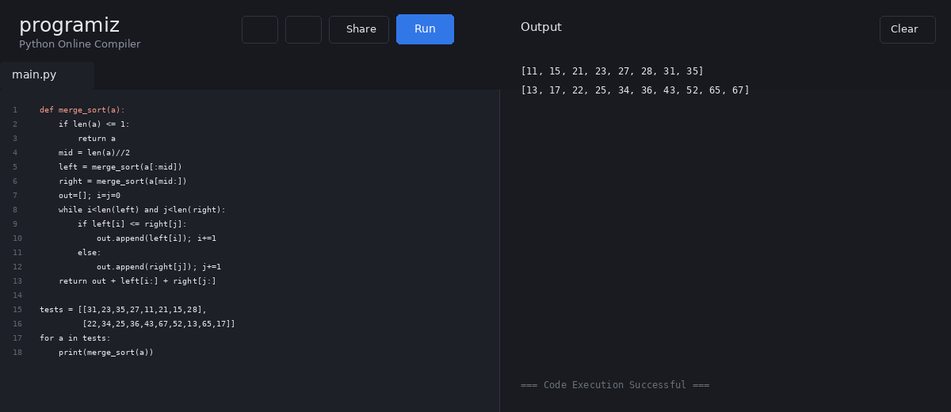

4. Merge Sort with Comparison Count
Question:
Implement Merge Sort on [12,4,78,23,45,67,89,1]. Modify it to count the number of comparisons made during sorting and print the count with the sorted array.
Test case 2:
[38,27,43,3,9,82,10] -> [3,9,10,27,38,43,82]
Code:
def merge_sort(a):
if len(a) <= 1:
return a, 0
m=len(a)//2
L,c1=merge_sort(a[:m])
R,c2=merge_sort(a[m:])
i=j=0; out=[]; c=c1+c2
while i<len(L) and j<len(R):
c += 1
if L[i] <= R[j]:
out.append(L[i]); i+=1
else:
out.append(R[j]); j+=1
return out+L[i:]+R[j:],c
for a in [[12,4,78,23,45,67,89,1],
[38,27,43,3,9,82,10]]:
s,c=merge_sort(a)
print("Sorted:",s)
print("Comparisons:",c)
Execution Screenshot:
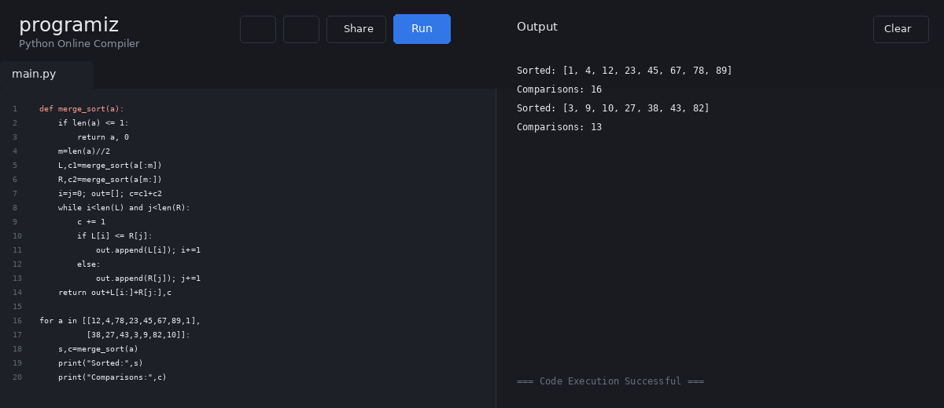

5. Quick Sort – First Element as Pivot
Question:
Given [10,16,8,12,15,6,3,9,5], perform Quick Sort using the first element as pivot. Show the array after partition and after recursive calls until sorted.
Expected sorted output: 3,5,6,8,9,10,12,15,16.
Also test:
[12,4,78,23,45,67,89,1]
[38,27,43,3,9,82,10]
Code:
def quick_sort(a, steps):
if len(a) <= 1:
return a
pivot=a[0]
left=[x for x in a[1:] if x<=pivot]
right=[x for x in a[1:] if x>pivot]
steps.append(left+[pivot]+right)
return quick_sort(left,steps)+[pivot]+quick_sort(right,steps)
a=[10,16,8,12,15,6,3,9,5]
steps=[]
result=quick_sort(a,steps)
print("Partition steps:")
for s in steps: print(s)
print("Sorted:",result)
Execution Screenshot:
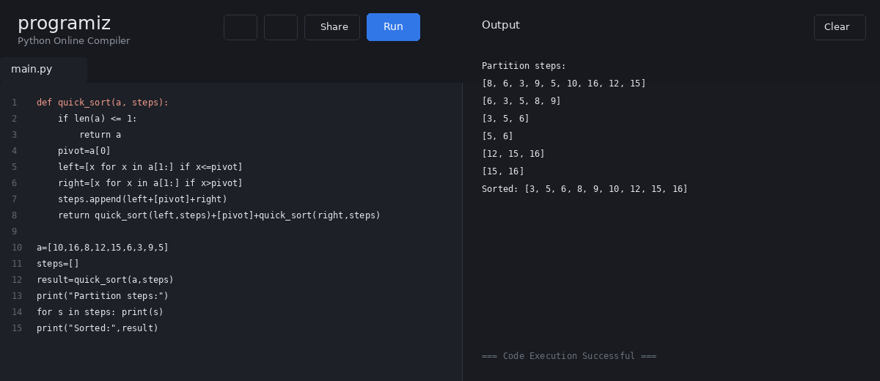

6. Quick Sort – Middle Element as Pivot
Question:
Implement Quick Sort using the middle element as the pivot. Show the array after each partition and recursive call.
Input:
[19,72,35,46,58,91,22,31]
Output:
19,22,31,35,46,58,72,91
Test cases:
[31,23,35,27,11,21,15,28]
[22,34,25,36,43,67,52,13,65,17]
Code:
def quick_sort(a, steps):
if len(a)<=1:
return a
pivot=a[len(a)//2]
left=[x for x in a if x<pivot]
equal=[x for x in a if x==pivot]
right=[x for x in a if x>pivot]
steps.append(left+equal+right)
return quick_sort(left,steps)+equal+quick_sort(right,steps)
a=[19,72,35,46,58,91,22,31]
steps=[]
result=quick_sort(a,steps)
for s in steps: print(s)
print("Sorted:",result)
Execution Screenshot:
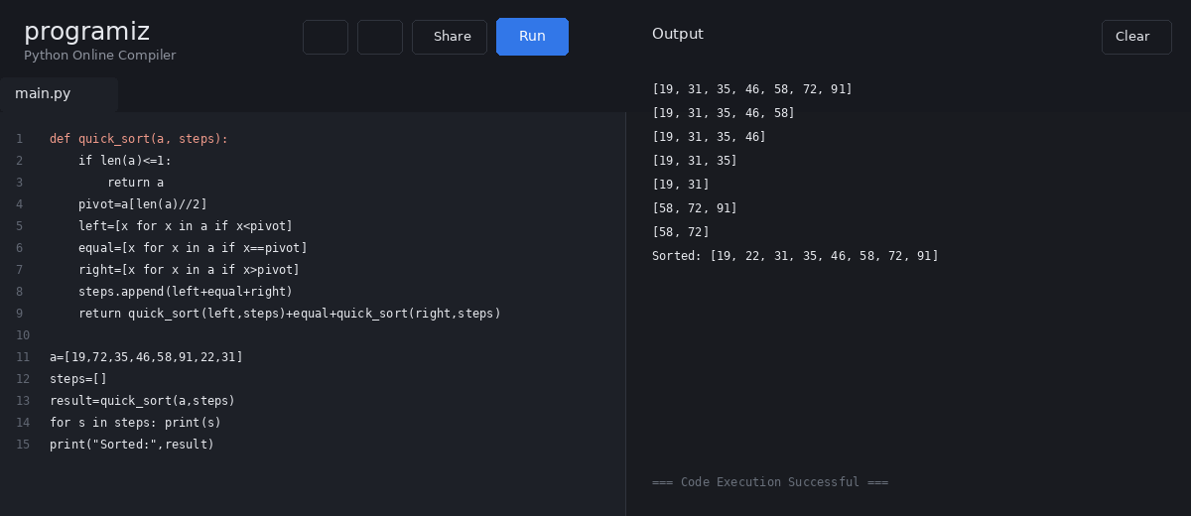

7. Binary Search with Comparison Count
Question:
Implement the Binary Search algorithm in a programming language of your choice and test it on the array 5,10,15,20,25,30,35,40,45 to find the position of 20. Execute your code and provide the index/position of 20. Modify the implementation to count comparisons.
Test cases:
[10,20,30,40,50,60], key=50 -> 5
[21,32,40,54,65,76,87], key=32 -> 2
Code:
def binary_search(a,key):
lo,hi=0,len(a)-1
comps=0
while lo<=hi:
mid=(lo+hi)//2
comps+=1
if a[mid]==key:
return mid+1,comps
if a[mid]<key: lo=mid+1
else: hi=mid-1
return -1,comps
tests=[([5,10,15,20,25,30,35,40,45],20),
([10,20,30,40,50,60],50),
([21,32,40,54,65,76,87],32)]
for a,k in tests:
print(binary_search(a,k))
Execution Screenshot:
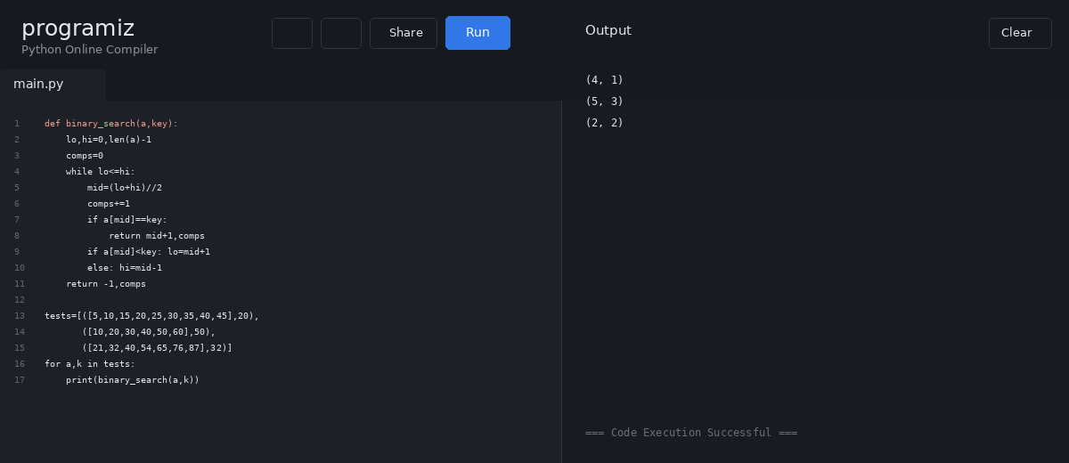

8. Binary Search – Mid-Point Steps
Question:
Find the position of 31 in the sorted array [3,9,14,19,25,31,42,47,53] using Binary Search. Show mid-point calculations and the steps involved. Explain what happens if the array is not sorted and how this affects correctness.
Test cases:
[13,19,24,29,35,41,42], key=42 -> position 7
[20,40,60,80,100,120], key=60 -> position 3
Code:
def binary_search_steps(a,key):
lo,hi=0,len(a)-1
while lo<=hi:
mid=(lo+hi)//2
print("lo =",lo,"mid =",mid,"hi =",hi,
"value =",a[mid])
if a[mid]==key:
return mid+1
if a[mid]<key: lo=mid+1
else: hi=mid-1
return -1
a=[3,9,14,19,25,31,42,47,53]
print("Position:",binary_search_steps(a,31))
Execution Screenshot:
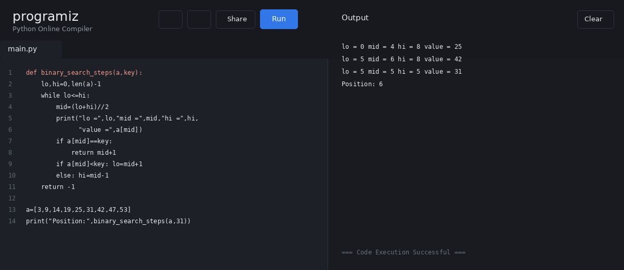

9. K Closest Points to the Origin
Question:
Given points on the X-Y plane and k, return the k closest points to the origin (0,0).
(i) [[1,3],[-2,2],[5,8],[0,1]], k=2 -> [[-2,2],[0,1]]
(ii) [[1,3],[-2,2]], k=1 -> [[-2,2]]
(iii) [[3,3],[5,-1],[-2,4]], k=2 -> [[3,3],[-2,4]]
Code:
def k_closest(points,k):
points=sorted(points,
key=lambda p:p[0]**2+p[1]**2)
return points[:k]
tests=[
([[1,3],[-2,2],[5,8],[0,1]],2),
([[1,3],[-2,2]],1),
([[3,3],[5,-1],[-2,4]],2)]
for p,k in tests:
print(k_closest(p,k))
Execution Screenshot:
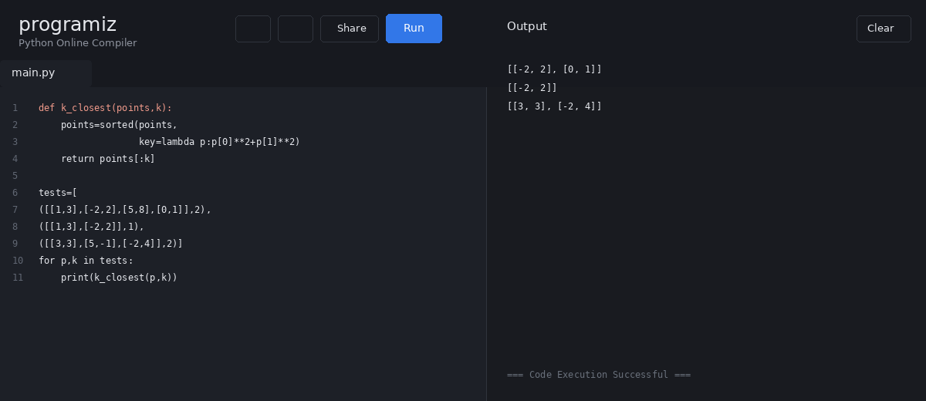

10. 4Sum II – Count Tuples
Question:
Given four integer lists A, B, C, D, compute how many tuples (i,j,k,l) satisfy A[i]+B[j]+C[k]+D[l] = 0.
(i) A=[1,2], B=[-2,-1], C=[-1,2], D=[0,2] -> 2
(ii) A=[0], B=[0], C=[0], D=[0] -> 1
Code:
def four_sum_count(A,B,C,D):
count=0
for a in A:
for b in B:
for c in C:
for d in D:
if a+b+c+d==0:
count+=1
return count
print(four_sum_count(
[1,2],[-2,-1],[-1,2],[0,2]))
print(four_sum_count([0],[0],[0],[0]))
Execution Screenshot:
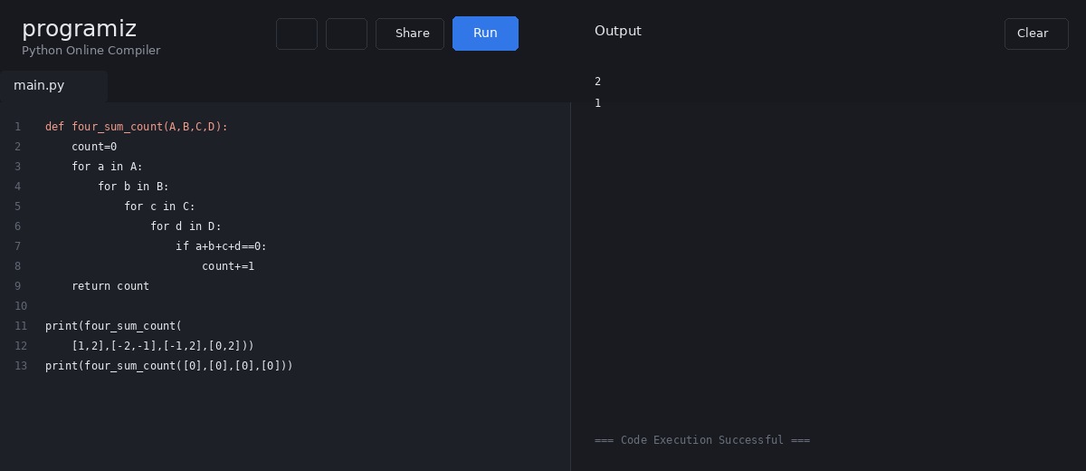

11. Median of Medians – k-th Smallest
Question:
Implement the Median of Medians algorithm to find the k-th smallest element with efficient worst-case behavior.
arr=[12,3,5,7,19], k=2 -> 5
arr=[12,3,5,7,4,19,26], k=3 -> 5
arr=[1,2,3,4,5,6,7,8,9,10], k=6 -> 6
Code:
def median_of_medians(a,k):
if len(a)<=5:
return sorted(a)[k-1]
groups=[a[i:i+5] for i in range(0,len(a),5)]
med=[sorted(g)[len(g)//2] for g in groups]
pivot=median_of_medians(med,(len(med)+1)//2)
low=[x for x in a if x<pivot]
eq=[x for x in a if x==pivot]
high=[x for x in a if x>pivot]
if k<=len(low): return median_of_medians(low,k)
if k<=len(low)+len(eq): return pivot
return median_of_medians(high,k-len(low)-len(eq))
tests=[([12,3,5,7,19],2),
([12,3,5,7,4,19,26],3),
(list(range(1,11)),6)]
for a,k in tests:
print(median_of_medians(a,k))
Execution Screenshot:
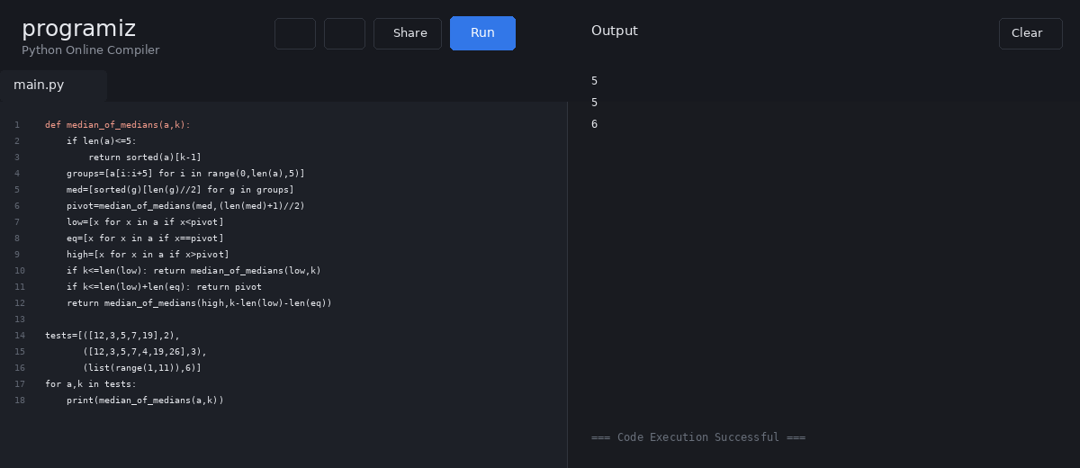

12. Median of Medians Function
Question:
Implement median_of_medians(arr,k) that takes an unsorted array and integer k and returns the k-th smallest element.
Inputs:
[1,2,3,4,5,6,7,8,9,10], k=6
[23,17,31,44,55,21,20,18,19,27], k=5
Code:
def median_of_medians(a,k):
if len(a)<=5:
return sorted(a)[k-1]
groups=[a[i:i+5] for i in range(0,len(a),5)]
med=[sorted(g)[len(g)//2] for g in groups]
pivot=median_of_medians(med,(len(med)+1)//2)
low=[x for x in a if x<pivot]
eq=[x for x in a if x==pivot]
high=[x for x in a if x>pivot]
if k<=len(low): return median_of_medians(low,k)
if k<=len(low)+len(eq): return pivot
return median_of_medians(high,k-len(low)-len(eq))
print(median_of_medians(
[1,2,3,4,5,6,7,8,9,10],6))
print(median_of_medians(
[23,17,31,44,55,21,20,18,19,27],5))
Execution Screenshot:
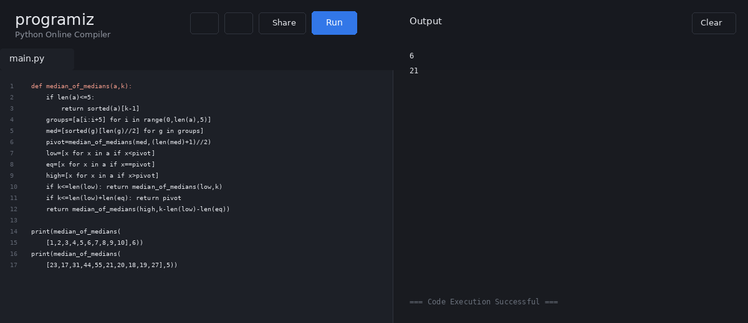

13. Meet in the Middle – Closest Subset Sum
Question:
Implement Meet in the Middle. Given an integer set and target sum, find a subset whose sum is closest to the target.
a) Set={45,34,4,12,5,2}, Target=42
b) Set={1,3,2,7,4,6}, Target=10
Code:
def closest_subset(a,target):
best=None
for mask in range(1<<len(a)):
sub=[a[i] for i in range(len(a)) if mask>>i&1]
s=sum(sub)
if best is None or abs(s-target)<abs(best[1]-target):
best=(sub,s)
return best
print(closest_subset([45,34,4,12,5,2],42))
print(closest_subset([1,3,2,7,4,6],10))
Execution Screenshot:
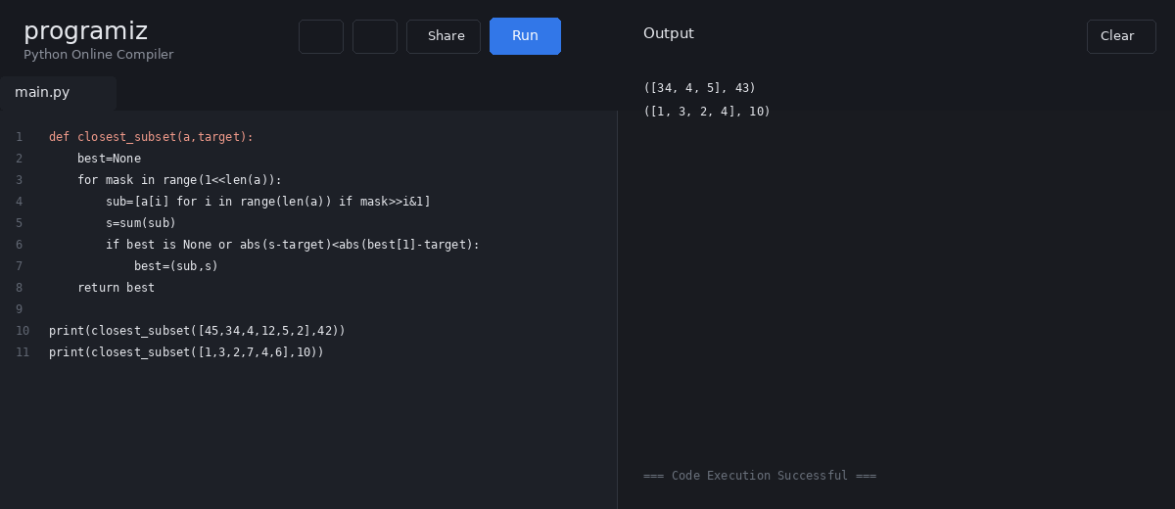

14. Meet in the Middle – Exact Subset Sum
Question:
Given a large array and an exact sum E, determine whether any subset sums exactly to E. Return True if such a subset exists, otherwise False.
a) E={1,3,9,2,7,12}, exact Sum=15
b) E={3,34,4,12,5,2}, exact Sum=15
Code:
def exact_subset(a,target):
for mask in range(1<<len(a)):
sub=[a[i] for i in range(len(a)) if mask>>i&1]
if sum(sub)==target:
return True,sub
return False,[]
print(exact_subset([1,3,9,2,7,12],15))
print(exact_subset([3,34,4,12,5,2],15))
Execution Screenshot:
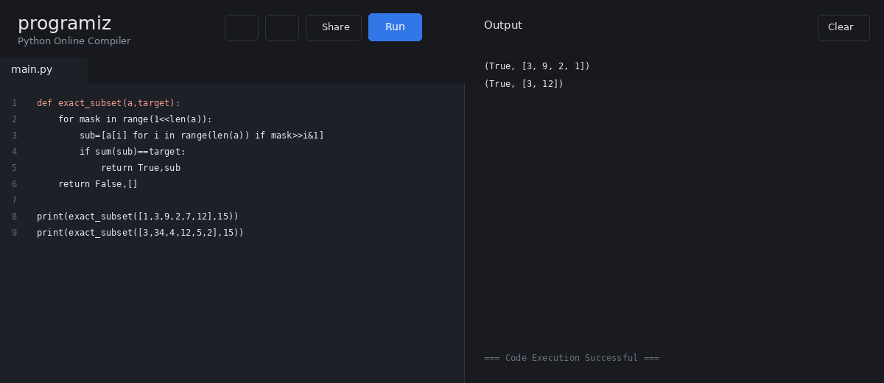

15. Strassen Matrix Multiplication
Question:
Given two 2×2 matrices, use Strassen's matrix multiplication algorithm to compute C=A×B.
Source test case:
A = [[1,7],[3,5]]
B = [[6,8],[4,2]]
The source document states an expected output, but direct matrix multiplication of these displayed matrices gives [[34,22],[38,34]].
Code:
def strassen(A,B):
a,b=A[0]; c,d=A[1]
e,f=B[0]; g,h=B[1]
p1=a*(f-h); p2=(a+b)*h
p3=(c+d)*e; p4=d*(g-e)
p5=(a+d)*(e+h); p6=(b-d)*(g+h)
p7=(a-c)*(e+f)
return [[p5+p4-p2+p6, p1+p2],
[p3+p4, p1+p5-p3-p7]]
A=[[1,7],[3,5]]
B=[[6,8],[4,2]]
print(strassen(A,B))
Execution Screenshot:
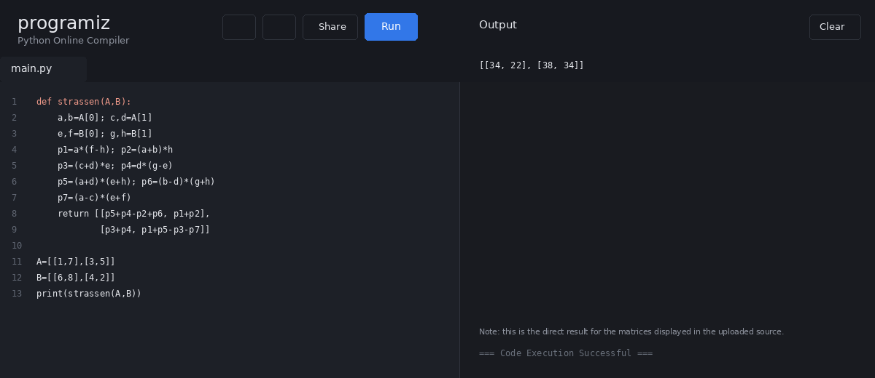

16. Karatsuba Multiplication
Question:
Given X=1234 and Y=5678, use the Karatsuba algorithm to compute Z=X×Y.
Input: x=1234, y=5678
Expected output: z=1234×5678=7016652
Code:
def karatsuba(x,y):
if x<10 or y<10:
return x*y
n=max(len(str(x)),len(str(y)))
m=n//2
p=10**m
a,b=divmod(x,p)
c,d=divmod(y,p)
ac=karatsuba(a,c)
bd=karatsuba(b,d)
abcd=karatsuba(a+b,c+d)
return ac*p*p + (abcd-ac-bd)*p + bd
x,y=1234,5678
print("Product:",karatsuba(x,y))
Execution Screenshot:
